Jss2 Basic technology 3rd term e_note

Week 1 revision of last term works

Week 2 belt and chain drive

Week 3 belt and chain drives (cont)

Week 4 Gears

Week 5 Gear ratio and speed

Week 6 hydraulie and pneumatics machine

Week 7 building construction

Week 8 setting out

Week 9 building service

Week10; building project

Week11; revision

Week12; exam

Week1 . revision of last term work

v**polygon** is a [plane](https://en.wikipedia.org/wiki/Plane_%28mathematics%29) [figure](https://en.wikipedia.org/wiki/Shape) that is bounded by a finite chain of straight [line segments](https://en.wikipedia.org/wiki/Line_segment) closing in a loop to form a closed [polygonal chain](https://en.wikipedia.org/wiki/Polygonal_chain) or *circuit*. These segments are called its [*edges*](https://en.wikipedia.org/wiki/Edge_%28geometry%29) or *sides*, and the points where two edges meet are the polygon's [*vertices*](https://en.wikipedia.org/wiki/Vertex_%28geometry%29) (singular: vertex) or *corners*. The interior of the polygon is sometimes called its *body*. An ***n*-gon** is a polygon with *n* sides; for example, a [triangle](https://en.wikipedia.org/wiki/Triangle) is a 3-gon. A polygon is a 2-dimensional example of the more general [polytope](https://en.wikipedia.org/wiki/Polytope) in any number of dimensions.

The basic geometrical notion of a polygon has been adapted in various ways to suit particular purposes. Mathematicians are often concerned only with the bounding closed polygonal chain and with [simple polygons](https://en.wikipedia.org/wiki/Simple_polygon) which do not self-intersect, and they often define a polygon accordingly. A polygonal boundary may be allowed to intersect itself, creating [star polygons](https://en.wikipedia.org/wiki/Star_polygon) and other [self-intersecting polyg](https://en.wikipedia.org/wiki/List_of_self-intersecting_polygons)

**Quadrangles – Four Sides**

Four-sided polygons, or quadrangles, include squares, rectangles and rhombuses depending on the lengths of their sides and the angles between their sides.

The internal angles of all quadrangles add up to 360°.

Squares, rectangles and rhombuses are all types of parallelograms: they have opposite sides that are equal in length and opposite and equal angles.

**More than Four Sides**

A five-sided shape is called a pentagon.

A six-sided shape is a hexagon, a seven-sided shape a heptagon, while an octagon has eight sides…

There are names for many different types of polygons, and usually the number of sides is more important than the name of the shape.

There are two main types of polygon - regular and irregular.

A **regular polygon** has equal length sides with equal angles between each side. Any other polygon is an **irregular polygon**, which by definition has unequal length sides and unequal angles between sides.

**Circles and shapes that include curves are not polygons** - a polygon, by definition, is made up of straight lines. See our pages on **[circles and curved shapes](https://www.skillsyouneed.com/num/curved-shapes.html)** for more.

**Angles Between Sides**

The angles between the sides of shapes are important when defining and working with polygons. Angles.here is a useful formula for finding out the total (or sum) of internal angles for any polygon, that is:

(number of sides - 2) × 180°

**Example:**

For a pentagon (a five-sided shape) the calculation would be:

5 - 2 = 3

3 × 180 = 540°.

**The sum of internal angles for any (not complex) pentagon is 540°.**

Furthermore, if the shape is a **regular polygon** (all angles and length of sides are equal) then you can simply divide your answer, from above,with the number of sides to find each internal angle.

540 ÷ 5 = 108°.

A **regular** pentagon therefore has five angles each equal to 108°.

**The Length of the Sides**

**As well as the number of sides and the angles between sides, the length of each side of shapes is also important.**

The length of the sides of a plane shape enables you to calculate the shape’s **perimeter** (the distance around the outside of the shape) and **area** (the amount of space inside the shape).

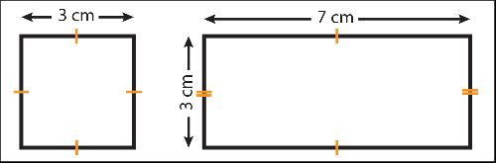

If your shape is a regular polygon (such as a square in the example above) then it is only necessary to measure one side as, by definition, the other sides of a regular polygon are the same length. It is common to use tick marks to show that all sides are an equal length.

In the example of the rectangle we needed to measure two sides - the two unmeasured sides are equal to the two measured sides.

**It is common for some dimensions not to be shown for more complex shapes. In such cases missing dimensions can be calculated.**

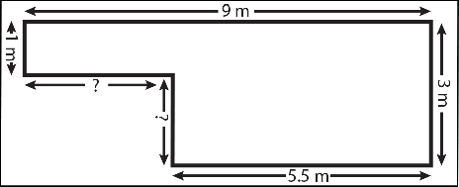

In the example above, two lengths are missing.

The missing horizontal length can be calculated. Take the shorter horizontal known length from the longer horizontal known length.

9m - 5.5m = 3.5m.

The same principle can be used to work out the missing vertical length. That is:

3m - 1m = 2m.

**Bringing All the Information Together: Calculating the Area of Polygons**

The simplest and most basic polygon for the purposes of calculating area is the quadrangle. To obtain the area, you simply multiple length by vertical height.

For rhombuses, note that vertical height is **NOT** the length of the sloping side, but the vertical distance between the two horizontal lines.

This is because a rhombus is essentially a rectangle with a triangle cut off one end and pasted onto the other:

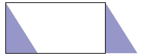

You can see that if you remove the left hand blue triangle, and stick it onto the other end, the rectangle becomes a rhombus.

The area is length (the top horizontal line) multiplied by height, the vertical distance between the two horizontal lines.

To work out the area of a **triangle**, you multiple length by vertical height (that is, the vertical height from the bottom line to the top point), and halve it. This is essentially because a triangle is half a rectangle.

**To calculate the area of any regular polygon**, the easiest way is to divide it into triangles, and use the formula for the area of a triangle.

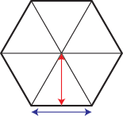

So, for a hexagon, for example:

You can see from the diagram that there are six triangles.

QUESTIONS

1.Define polygon

2.draw pentagon [AB 50MM]

Week2 Belt and chain drive

# Difference Between Chain Drive and Belt Drive

• Categorized under [Technology](http://www.differencebetween.net/category/technology/) | 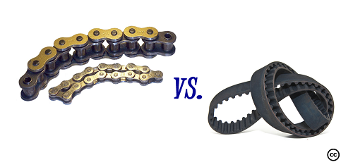

## Chain Drive vs. Belt Drive

Both a chain drive and a belt dive are part of mechanisms that allow locomotion and a transfer of power within a particular piece of machinery. The usual application of a chain drive and a belt drive is to transfer power or as a method to move objects, like hoisting or conveying. Chain drives and belt drives are often used in many [vehicles](http://www.differencebetween.net/category/object/auto-object/) (like bicycles, motorcycles, and automobiles) as well as other mSechanical applications, including garage doors.

Both chain drives and belt drives are designed as continuous and endless loops that move when the engine is running or in use. The chain drive, as its name implies, is made up of chains with special structures like teeth on one side and a corresponding etch on the other side (drive shafts). The chain drive works when the two sides link together, which encourages the movement of the chain as well as power. The designs and structures also allow the chain to keep and hold it in one place and one direction.

On the other hand, the belt drive is a smooth and wide span of synthetic material. The belt drive itself can be made from rubber, plastic, and other synthetic substances.  
Each kind of drive has its own set of advantages and disadvantages.

The chain drive is stronger and more durable because it is made of metal. It is also more dependable to use and easier to repair. Moreover, it is easier to change gears in the instance when the chain is broken. However, the chain drive’s downsides include requiring lubrication to run smoothly and seamlessly, and the fact that the chain can get stuck in the links or mangle itself while on the run. Simple chain drives usually contain two gears; the more complicated designs tend to have two or more gears in the design. The additional gears are called “idle gears” and usually don’t contribute to the drive and its overall ratio. The only thing that impacts the gear ratio is the number of teeth in the first and last gears.

Chain drives are usually seen in bikes, motorcycles, and automobiles. They are also used in many industries such as the military (for tanks) and in the mining industry. The classification for a chain drive is as follows: roller chain, double pitch roller chain, silent (inverted tooth) chain, detachable link chain, and engineering steel chain. There are also three types of load classification for chain drives: smooth load, moderate shock load, and heavy shock load.  
On the other hand, a belt drive is best used for machines and is very useful in inspection for damage or wear. The surface of the belt can more easily show evidence of the mentioned imperfections and can be an indication that purchasing a replacement may be neccesarry. Another advantage of the belt drive is that it requires fewer adjustments and is quieter, cleaner, and runs more smoothly compared to the chain drive. This type of drive doesn’t require lubrication, which can be considered as an added cost to a machine’s maintenance. The bad thing about belt drives is the fact that they often expire earlier compared to the chain drive. Belt drives can also slip or snap if the belt isn’t maintained or at least inspected for signs of damage and wear.

The types of belt drives are diverse. The list of their kinds include flat belts, round belts, vee belts, multi-groove belts, ribbed belt, film belts, metal belts, endless round belts, timing belts, specialty belts, rolling roads, and flying rope.

### Summary:

1.Both chain drives and belt drives are methods to transfer power and objects within a machine. The main difference between the two drives is that a chain drive is powered by a chain loop, while a belt drive is powered by a belt.  
2.Another notable difference is the material of the drive. Chain drives are made of metal, which makes them more durable and stronger compared to a belt. The metal chain is designed to have a design that corresponds to the other side. On the other hand, the belt drive is made of synthetic materials,

ADVANTAGES OF BELT DRIVE

1. Belt drives are simple are economical.
2. They don’t need parallel shafts.
3. Belts drives are provided with overload and jam protection.
4. Noise and vibration are damped out. Machinery life is increased because load fluctuations are shock-absorbed.
5. They are lubrication-free. They require less maintenance cost.
6. Belt drives are highly efficient in use (up to 98%, usually 95%).
7. They are very economical when the distance between shafts is very large.

**DISADVANTAGES OF BELT DRIVE-**

1. In Belt drives, angular velocity ratio is not necessarily constant or equal to the ratio of pulley diameters, because of slipping and stretching.
2. Heat buildup occurs. Speed is limited to usually 35 meters per second. Power transmission is limited to 370 kilowatts.
3. Operating temperatures are usually restricted to –35 to 85°C.
4. Some adjustment of center distance or use of an idler pulley is necessary for wearing and stretching of belt drive compensation.
5. Belt drives are simple are economical.
6. They don’t need parallel shafts.
7. Belts drives are provided with overload and jam protection.
8. Noise and vibration are damped out. Machinery life is increased because load fluctuations are shock-absorbed.
9. They are lubrication-free. They require less maintenance cost.
10. Belt drives are highly efficient in use (up to 98%, usually 95%).
11. They are very economical when the distance between shafts is very large.

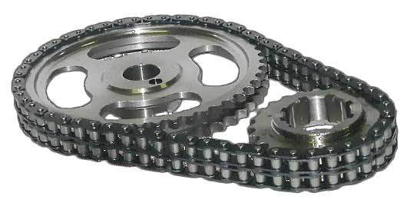

**ADVANTAGES OF CHAIN DRIVE-**

1. • Positive non-slip drives
2. • Efficiency is high
3. • Employed for small as well as large centre distances up to 8m.
4. • Permit high velocity ratio up to 8:1
5. • Transmit more power than belt drives
6. • They produce less load on shafts compared to belt drives

**DISADVANTAGES OF CHAIN DRIVE-**

1. • Driving and driven shafts should be in perfect alignment.
2. • Requires good lubrication
3. • High initial cost

**GEAR DRIVE→**

Gear drives find a very prominent place in mechanical power transmission. Gear drives are preferred when considerable power has to be transmitted over a short distance positively with a constant velocity ratio.

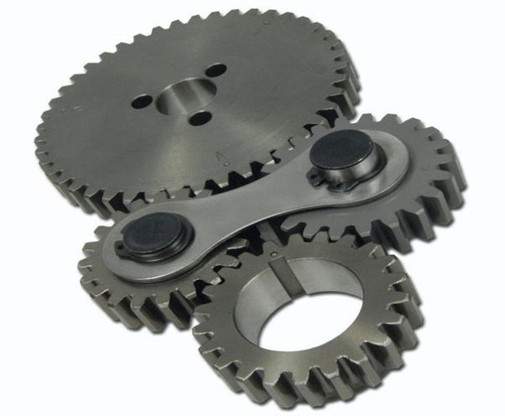

**ADVANTAGES OF GEAR DRIVE-**

1. They are positive non-slip drives.
2. Most convenient for very small centre distances.
3. By using different types of gears, it will be possible to transmit the power when the axes of the shafts are not only parallel, but even when nonparallel, intersecting, non-intersecting and co- planar or non-coplanar.
4. The velocity ratio will remain constant throughout.
5. They can be employed conveniently for low, medium and high power transmission.
6. Any velocity ratio as high as, even up to 60:1 can be obtained.
7. They have very high transmission efficiency.
8. Gears can be cast in a wide range of both metallic and non-metallic materials.
9. If required gears may be cast integral with the shafts.
10. Gears are employed for wide range of applications like in watches, precision measuring instruments, machine tools, gear boxes fitted in automobiles, aero engines, etc.

**DISADVANTAGES OF GEAR DRIVE-**

1. They are not suitable for shafts of very large centre distances.
2. They always require some kind of lubrication.
3. At very high speeds noise and vibrations will be more.
4. They are not economical because of the increased cost of production of precision gears.
5. Use of large number of gear wheels in gear trains increases the weight of the mach

### Questions

* [What are the advantages of using a belt drive over a chain drive?](https://www.quora.com/What-are-the-advantages-of-using-a-belt-drive-over-a-chain-drive)
* [Why would you use a belt drive instead of a chain drive?](https://www.quora.com/Why-would-you-use-a-belt-drive-instead-of-a-chain-drive)
* Which is more efficient: gear drive or belt drive?What are the advantages of gear drives?What is slip in belt drives?Ask New QuestionAnswered 1d ago

Gear drives are used for short distance power transmission, chain drive and belt drive are used for power transmission in a longer distance. Chain drive is used for power transmission with more efficiency, in belt drive sometimes slip occurs.

The advantage of gear drives is the power transmission with high efficiency means it can transmit almost all the power from driven to driver in very high speed. And its disadvantage is that we can not transmit the power to a longer distance.

In chain drive the basic advantage is that we can transmit the power with good efficiency to a longer distance.

Belt Drive:- It is Type of Power transmission which done through by using belt mounted on two pulley made up of rubber, Cot

Disadvantages:-

1.Slip And Creep Occur

2.Wear of belt

3. Elongation of belt after continuous used

Chain Drive :- It is one of the type of power transmission by means of chain mounted on sprockets.

Advantages:-

1.More Power Transmission

2. No slip and creep occur

3.ast power transmission

Disadvantages:-

1.Lubrication Required

2. Noisy Transmission

3. Complicated

4. Can transmit power upto 500mm

Gear Drive:- It is a type of power transmission by means of two gears mesh to transmit a power from one shaft to another.

Advantages:-

1.Quick Transmission

2. No Slip and creep occur

3. Widely used in Automobile

Disadvantages:-

1.Lubrication Required

2. Wear occur

3. Can transmit power upto 300mm

### Questions

### 1.What is the use of a belt drive? 2. Why do we prefer a chain drive over a belt drive? 3.Why is a belt drive called a flexible drive?A



Week 4. gears A **gear** or **cogwheel** is a [rotating](https://en.wikipedia.org/wiki/Rotating) [machine](https://en.wikipedia.org/wiki/Machine_%28mechanical%29) part having cut *teeth*, or cogs, which mesh with another toothed part to transmit [torque](https://en.wikipedia.org/wiki/Torque). Geared devices can change the speed, torque, and direction of a [power source](https://en.wikipedia.org/wiki/Power_%28physics%29). Gears almost always produce a change in torque, creating a [mechanical advantage](https://en.wikipedia.org/wiki/Mechanical_advantage), through their [gear ratio](https://en.wikipedia.org/wiki/Gear_ratio), and thus may be considered a [simple machine](https://en.wikipedia.org/wiki/Simple_machine). The teeth on the two meshing gears all have the same shape.[[1]](https://en.wikipedia.org/wiki/Gear#cite_note-1) Two or more meshing gears, working in a sequence, are called a [gear train](https://en.wikipedia.org/wiki/Gear_train) or a [*transmission*](https://en.wikipedia.org/wiki/Transmission_%28mechanics%29). A gear can mesh with a linear toothed part, called a rack, thereby producing [translation](https://en.wikipedia.org/wiki/Translation_%28physics%29) instead of rotation.

The gears in a transmission are analogous to the wheels in a crossed, belt [pulley](https://en.wikipedia.org/wiki/Pulley) system. An advantage of gears is that the teeth of a gear prevent slippage.

When two gears mesh, if one gear is bigger than the other, a mechanical advantage is produced, with the [rotational speeds](https://en.wikipedia.org/wiki/Rotational_speed), and the torques, of the two gears differing in proportion to their diameters.

In transmissions with multiple gear ratios—such as bicycles, motorcycles, and cars—the term "gear" as in "first gear" refers to a gear ratio rather than an actual physical gear. The term describes similar devices, even when the gear ratio is [continuous](https://en.wiktionary.org/wiki/continuous) rather than [discrete](https://en.wiktionary.org/wiki/discrete), or when the device does not actually contain gears, as in a [continuously variable transmission](https://en.wikipedia.org/wiki/Continuously_variable_transmission).[[2]](https://en.wikipedia.org/wiki/Gear#cite_note-2)

### Gear types

[Spur Gear](http://khkgears.net/product-category/spur-gears/)  
The most common and easy to produce parallel shaft cylindrical gears. Of a pair of gears, the larger one is called a gear and the smaller one a pinion.

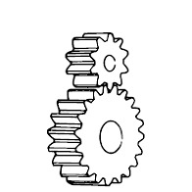

[Helical Gear](http://khkgears.net/product-category/helical-gears/)  
Quiet and able to transmit larger torque than spur gears. Cylindrical gears with spiral shaped tooth trace.

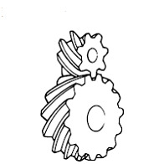

[Gear Rack](http://khkgears.net/product-category/gear-rack/)  
Changes rotary motion to linear motion. A set consisting of rectangular or circular rod shaped gear with mating small gear.

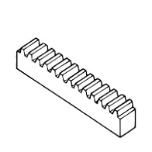

[Bevel Gear](http://khkgears.net/product-category/bevel-gears/)  
Cone shaped gears used in intersecting shaft applications. There are also bevel gears with spiral shaped tooth trace called spiral bevel gears.

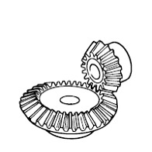

[Spiral Bevel Gear](http://khkgears.net/product-category/bevel-gears/)  
Cone shaped gears used in intersecting shaft applications. There are also bevel gears with straight shaped tooth trace called straight bevel gears.

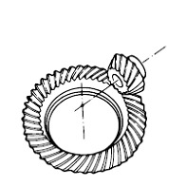

[Screw Gear](http://khkgears.net/product-category/screw-gears/)  
Used in offset shaft application. Shape wise, they are the same as helical gears.

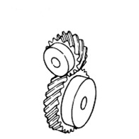

[Miter Gear](http://khkgears.net/product-category/miter-gears/)  
Type of bevel gears in which the pair is made of same number of teeth and used where speed reduction or increase is not needed.

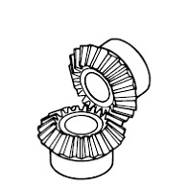

[Worm Gear](http://khkgears.net/new/worm_gear.html)  
Used when a large speed reduction is needed. Worm and worm gear set. Normally, different materials are used for worm and worm gear.

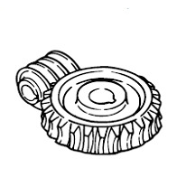

[Internal gear](http://khkgears.net/product-category/internal-gears/)  
Gear teeth are cut on the inside surface of hollow cylindrical forms and used in planetary gear systems. The gear teeth are cut using gear shaper machines.

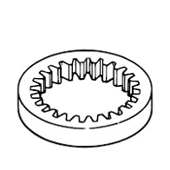

G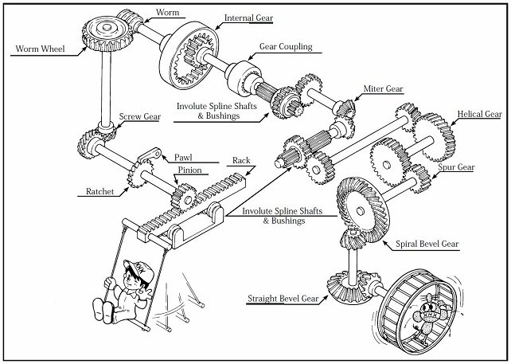

QUESTIONS

1. Define gear
2. Mention 5 types of gear

## Week 5 gear ratio

(Automotive engineering: Vehicle components, Engine, transmission, and exhaust)

The gear ratio is the ratio of the number of turns the [output](https://www.collinsdictionary.com/dictionary/english/output) [shaft](https://www.collinsdictionary.com/dictionary/english/shaft) makes when the [input](https://www.collinsdictionary.com/dictionary/english/input) shaft turns once.

A gearset with a 1-inch drive gear and a 2-inch driven gear has a gear ratio of 2:1. If the car is shifted into a higher gear, the gear ratio is reduced. Through selection of the proper gear ratio, torque applied to the drive wheels can be multiplied.

Lubricant in gear

|  |
| --- |
| **Lubrication of Gears** The purpose of lubricating gears is as follows: 1. Promote sliding between teeth to reduce the coefficient of friction. 2. Limit the temperature rise caused by rolling and sliding friction. To avoid difficulties such as tooth wear and premature failure, the correct lubricant must be chosen.  **Methods of Lubrication** There are three gear lubrication methods in general use:  **1. Grease lubrication.** Grease lubrication is suitable for any [gear](http://www.gearandrack.com/gear_information/gear_standards.html) system that is open or enclosed, so long as it runs at low speed. There are three major points regarding grease: 1.1 Choosing a lubricant with suitable viscosity. Lubricant with good fluidity is especially effective in an enclosed system. 1.2 Not suitable for use under high load and continuous operation. The cooling effect of grease is not as good as lubricating oil. So it may become a problem with temperature rise under high load and continuous operating conditions. 1.3 Proper quantity of grease. There must be sufficient grease to do the job. However, too much grease can be harmful, particularly in an enclosed system. Excess grease will cause agitation, viscous drag and result in power loss.  **2 Splash Lubrication(oil bath method)** Splash lubrication is used with an enclosed system. The rotating gears splash lubricant onto the [gear](http://www.gearandrack.com/gear_information/gear_info_a_00.html) system and bearings. It needs at least 3 m/s tangential speed to be effective. However, splash lubrication has several problems, two of them being oil level and temperature limitation. 2.1 Oil level. There will be excessive agitation loss if the oil level is too high. On the other hand, there will not be effective lubrication or ability to cool the [gears](http://www.gearandrack.com/gear_information/gear_standards.html) if the level is too low. Also, the oil level during operation must be monitored, as contrasted with the static level, in that the oil level will drop when the gears are in motion. This problem may be countered by raising the static level of lubricant or installing an o  **3 Forced-Circulation Lubrication** Forced-circulation lubrication applies lubricant to the contact portion of the teeth by means of an oil pump. There are drop, spray and oil mist methods of application. 3.1 Drop method: An oil pump is used to suck-up the lubricant and then directly drop it on the contact portion of the gears via a delivery pipe. 3.2. Spray method: An oil pump is used to spray the lubricant directly on the contact area of the [gears](http://www.gearandrack.com/gear_information/gear_standards.html). 3.3 Oil mist method: Lubricant is mixed with compressed air to form an oil mist that is sprayed against the contact region of the gears. It is especially suitable for [high-speed gearing](http://www.gearandrack.com/special_application_gears.html). Oil tank, pump, filter, piping and other devices are needed in the forced-lubrication system. Therefore, it is used only for special high-speed or [large gear](http://www.gearandrack.com/special_application_gears/coarse_pitch_gears.html) box applications.   1 Lubricant should maintain a proper viscosity to form a stable oil film at the specified temperature and speed of operation. 2 Lubricant should have the property to prevent the scoring failure of tooth surface while under high-pressure of load. 3 A good lubricant should not oxidize easily and must perform in moist and high-temperature environment for long duration. 4 The lubricant should have the property of isolating moisture and water from lubricant. If the lubricant foams under agitation, it will not provide a good oil film. Antifoam property is a vital requirement. Lubrication should be neutral and stable to prevent corrosion from rust that may mix into the oil.  Viscosity of Lubricant The correct viscosity is the most important consideration in choosing a proper lubricant of gears.  QUESTIONS 1. Define lubrication  2.list 2 types of lubricantss |
|  |

Week 8 setting out tools

## Procedure for Setting Out a Building Plan on Ground

**Fig.1: Example plan to be set out on the ground**

1. From the plan (fig 1), the centre line of the walls are calculated. Then the centre lines of the rooms are set out by setting perpendiculars in the ratio 3:4:5. Suppose the corner points are a, b, c, d, e, f and g which are marked by pegs with nails on top.

2. The setting of the corner point is checked according to diagonals ac, bd, cf and eg.

3. During excavation, the centre points a, b, c, d, e, f, g may be removed. Therefore the centre lines are extended and the centre points are marked about 2m away from the outer edge of excavation.

Thus the points A1, A2, B1, B2 and likewise, are marked outside the trench. Centre line are shown clearly by stretching thread or rope. The centre points fixed 2m away from the excavation are marked with sit out pegs.

4. From the plan details, the width of excavation to be done is also marked by thread with pegs at appropriate positions.

5. The excavation width is then marked by lime or by with furrow with spade.

6. If the plan is much to complicated and follows a zigzag pattern, then the centre pegs are kept at suitable positions according to site conditions.

QUESTIONS

1. what is site preparation

2.list 5 tools used for site preparetion

Week 9 building services

## system layout and pipe work

The water supply system must be designed to achieve appropriate water pressure and flow, and to avoid contamination to potable water.

On this page:

* Water pressure
* Water flow rate
* Flow rate and pipe size Acceptable Solutions
* System layout
* Connection to the mains supply
* Backflow
* Mains connection
* Pipe materials and specifications

Also see [installation](http://www.level.org.nz/water/water-supply/system-layout-and-pipework/pipework-installation/), [noise and air locks](http://www.level.org.nz/water/water-supply/system-layout-and-pipework/noise-and-air-locks-in-pipework/), [pipe jointing systems](http://www.level.org.nz/water/water-supply/system-layout-and-pipework/pipe-jointing-systems/), and [valves and controls](http://www.level.org.nz/water/water-supply/system-layout-and-pipework/valves-and-controls/).

As well as avoiding contamination and achieving the right pressure and flow, the system must be suitable for the temperature of water carried. A well-designed and installed system will also be durable, minimise noise from water flow and from problems such as water hammer, and support efficient use of water.

All water supply systems use a combination of pipes (of different dimensions and materials), valves and outlets to deliver water to building users. Some water supply systems also use storage tanks and pumps. Designing a water supply system involves getting all of these elements right so that clean water is delivered to the user at the appropriate rate and temperature.

### Water pressure

If the aim is to provide for building users’ needs while also using water efficiently, the right water pressure is crucial. If water pressure is too low, this will be inconvenient for building users – for example, because showers have poor water flow, and baths take a long time to fill. If pressure is too high, this will lead to wastage of water, as well as high wear and tear on the system.

Typically, new buildings in areas with mains water supply will have mains pressure systems. Existing buildings, and buildings that are not connected to mains water, may have low pressure systems or unequal pressure systems (with different pressures for hot and cold water supply).

As an example of the difference in water usage, a low pressure hot water system shower flow may average about 7 litres per minute, while a mains pressure shower may average around 12–20 litres per minute.

Mains pressure systems require pressure limiting and pressure reducing valves to control water pressure and temperature. Typically, pressure limiting or pressure reducing valves will be used to control pressure in mains-supplied hot water systems or where high pressure may lead to problems such as burst pipes.

Low pressure systems require few valves or controls. In low or unequal pressure systems, pressure can be increased to adequate levels by storing water in a header tank (typically in the ceiling space) so that gravity can be used to create water pressure. If a tank is being used, see the BRANZ publications Water and Plumbing for details of installation requirements.

Pressure can also be raised to adequate levels using a pressurising pump, in which case it may be necessary to use pressure limiting and pressure reducing valves.

### Water flow rate

The Building Code requires that sanitary fixtures and appliances have adequate water supply at an adequate flow rate.

As with water pressure, flow rates are crucial. A flow rate that is too high will result in water being wasted, whereas a flow rate that is too low will mean that sanitary fixtures and appliances don’t work properly.

Flow rate is affected by:

* Water pressure
* Pipe diameters – The smaller the internal diameter of the pipe, the lower the pressure and flow rate. (Note that pipes are generally referred to by their inside nominal diameter (DN), but it is actually the internal diameter that counts; a pipe rated as DN 15 may have an actual inside diameter ranging between 10–18 mm.)
* Water temperature – higher temperatures will tend to raise pressure and flow rates (note: also see materials below).

A flow regulator can be used to maintain a constant flow, independent of water pressure. As an example, if someone is in the shower and the kitchen tap is turned on full, the temperature and flow are likely to remain more stable if a flow regulator is used.

Limiting the flow for a tap or appliance to a reasonable rate helps balance the available pressure throughout the system. Regulating flow allows a simpler design and minimum pipe sizes as peak flow rates can be specified accurately and can also reduce noise, splashing taps, and water hammer.

Manufacturers’ recommendations must be referred to for pressure and flow information when selecting tempering valves and outlets (taps, mixers and shower heads).

Flow rate can also be controlled by specifying low-flow

|  |  |  |
| --- | --- | --- |
| **Acceptable flow rates for fixtures and appliances** | | |
| **Fixture** | **Flow rate (l/s) and temperature °C** |  |
| Basin | 0.1 at 45 °C |  |
| Bath | 0.3 at 45°C |  |
| Sink | 0.2 at 60°C (hot) and 0.2 (cold) |  |
| Shower | 0.1 at 42°C |  |
| Laundry tub | 0.2 at 60°C (hot) and 0.2 (cold) |  |
| Dishwasher and washing machine | 0.20 |  |
| *Adapted from G12/AS1 Table 3* | | |

The flow rates in Table 3 must be capable of being delivered simultaneously to the kitchen sink and one other fixture.

### System layout

In the design process, the layout of the plumbing system will largely follow room layout. Nonetheless, there are many things to consider which relate to Code compliance, building users’ comfort, and sustainability.

When planning a water supply layout, the following must be considered:

* Pipe runs and lengths – Keep pipe runs as short as possible. Pass pipes close to fixtures to minimise the number of branches and unnecessary elbows, tees and joints. Having longer pipe runs and more fixtures will reduce flow rate, increase heat losses, and increase use of materials
* Point of entry into the building – This should be into a utility space such as garage/laundry and include an accessible isolating valve, line strainer and pressure limiting valve (if required)
* Water heating system – Locate centrally to reduce the length of pipe runs to fixtures because longer pipe runs require more water to be drawn off before hot water is discharged. Install a separate point-of-use water heater for fixtures that are more than 10 m from the main water heater
* Noise prevention – Avoid running pipes over or near bedrooms and living areas.

### Backflow

Backflow is the unplanned reversal of flow of water (or water and contaminants) into the water supply system. The system must be designed and used to prevent contamination from backflow. See [backflow prevention](http://www.level.org.nz/water/water-supply/system-layout-and-pipework/backflow-prevention/) for more.

### Mains connection

Where the water source is a mains supply, the network utility operator is responsible for the water supplied to the property boundary. The property owner is then responsible for providing the pipework to bring the water into the building.

An isolating valve must be fitted at the point of connection to allow for maintenance and repair of the building’s water supply system if required.

### Pipe materials and specifications

The pipes used in a building must not contaminate potable water supply, and must be suitable for the water pressure, flow rate and temperature of water they will be carrying. This will be influenced by the materials used and also by other factors such as the wall thickness.

Other considerations are durability, ease of installation, cost, and sustainability. Common materials for domestic water supply include copper, polybutylene (PB), polyethylene (PE), polypropylene (PP-3 or PP Type 3), and cross-linked polyethylene (PEX).



[Pipe materials](http://www.level.org.nz/water/water-supply/system-layout-and-pipework/pipe-materials/)



[Pipe jointing systems](http://www.level.org.nz/water/water-supply/system-layout-and-pipework/pipe-jointing-systems/)



[Pipework installation](http://www.level.org.nz/water/water-supply/system-layout-and-pipework/pipework-installation/)



[Noise and air locks in pipework](http://www.level.org.nz/water/water-supply/system-layout-and-pipework/noise-and-air-locks-in-pipework/)



[Backflow prevention](http://www.level.org.nz/water/water-supply/system-layout-and-pipework/backflow-prevention/)



[Valves and controls](http://www.level.org.nz/water/water-supply/system-layout-and-pipework/valves-and-controls/)

QUESTIONS

1.Mention five used for house plumbing

2.Explain building services

Top of Form

Bottom of Form

week 10 Building project

week 11 revision

week 12exam

Top of Form

Bottom of Form